Implementation of TICK Stack in

a Dockerized Environment

# Stepwise description

Step1: Install InfluxDB

* First create a network
  + docker network create tick-net
* Check the network
  + docker network ls

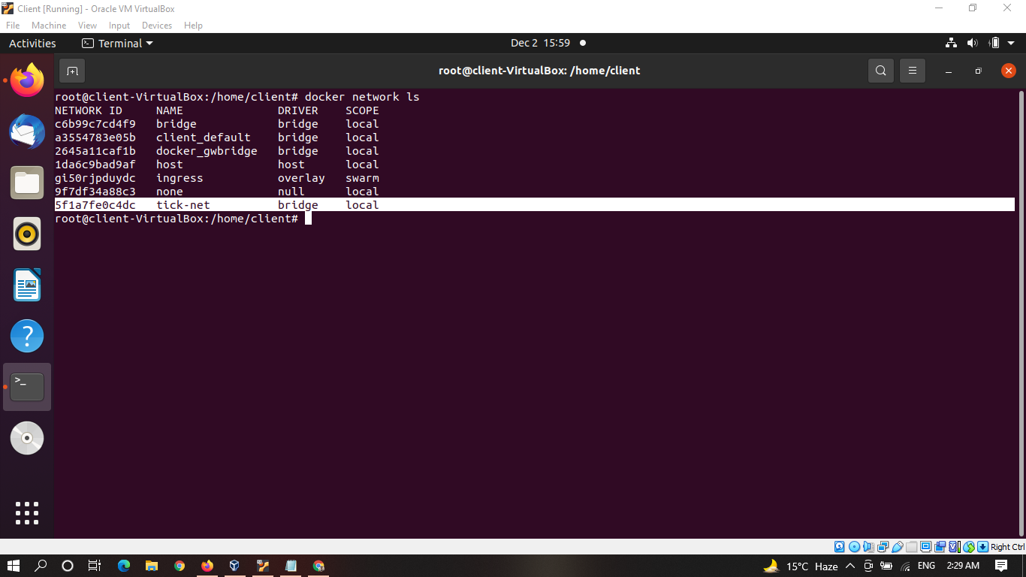

* Create our InfluxDB Container.
  + docker run -d --name influxdb -p 8086:8086 --net=tick-net -v influxdb:/var/lib/influxdb influxdb:1.8

Step2: Install telegraf

* Create a telegraf container.
  + docker run -d --name telegraf --net=container:influxdb telegraf

Step3: Install Chronograf

* Create a chronograf container
  + docker run -d --name chronograf -p 8888:8888 --net=tick-net chronograf --influxdb-url=http://influxdb:8086

Step4: Install kapacitor

* Create a kapacitor container.
  + docker run -d --name kapacitor --net=container:influxdb kapacitor

Step5: Showing all running containers

* Type following command
  + docker ps

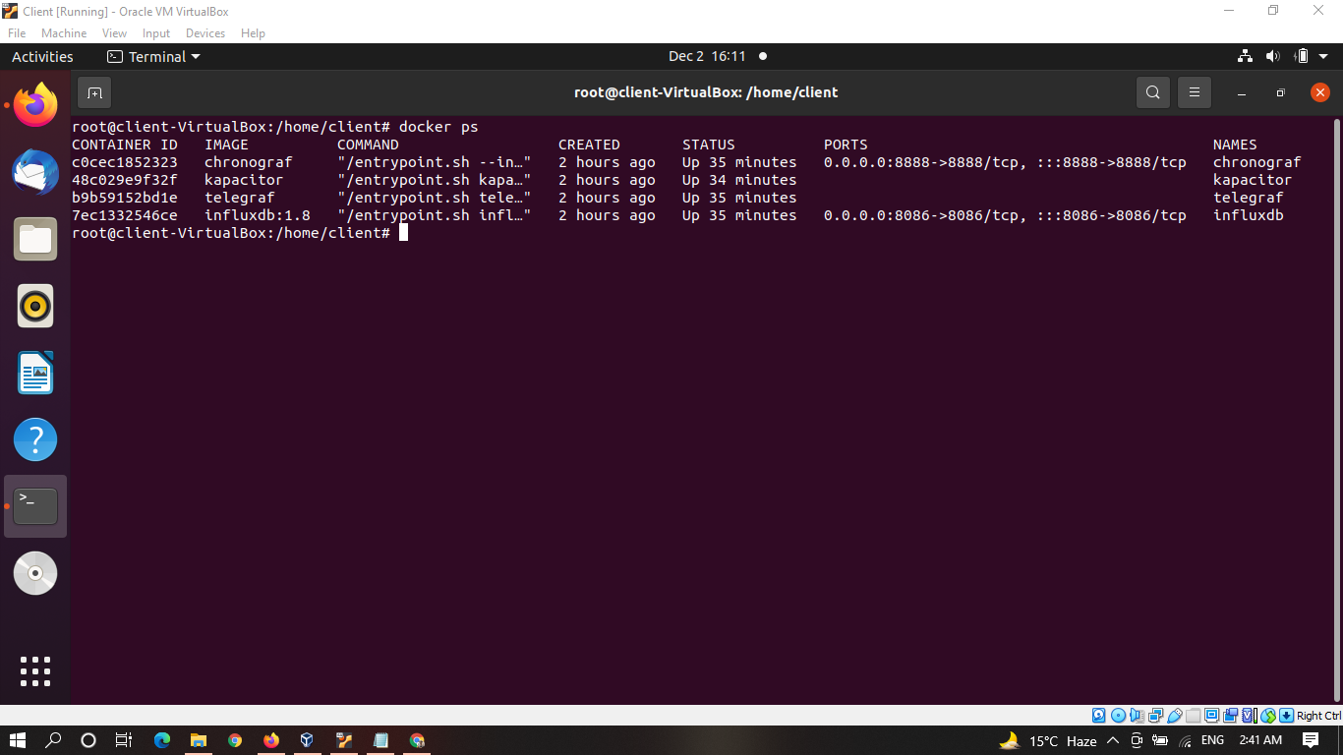

Step6: Showing the Connections configuration from Chronograf UI.

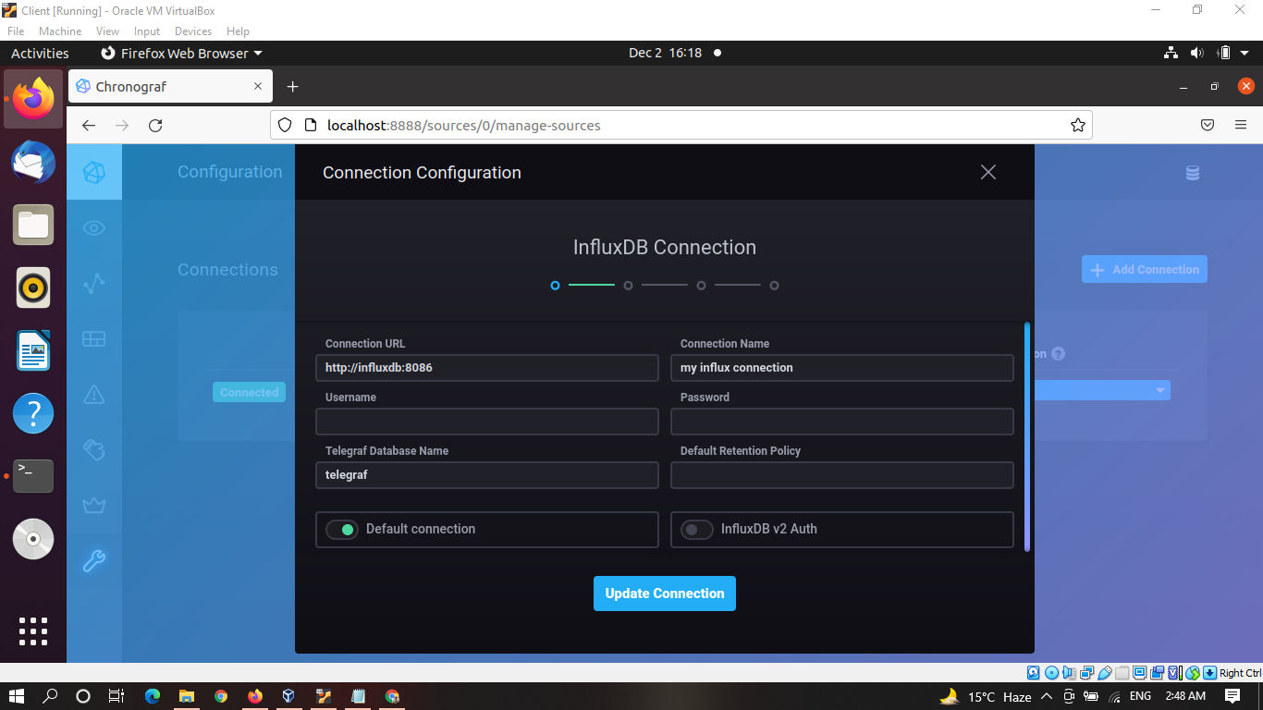

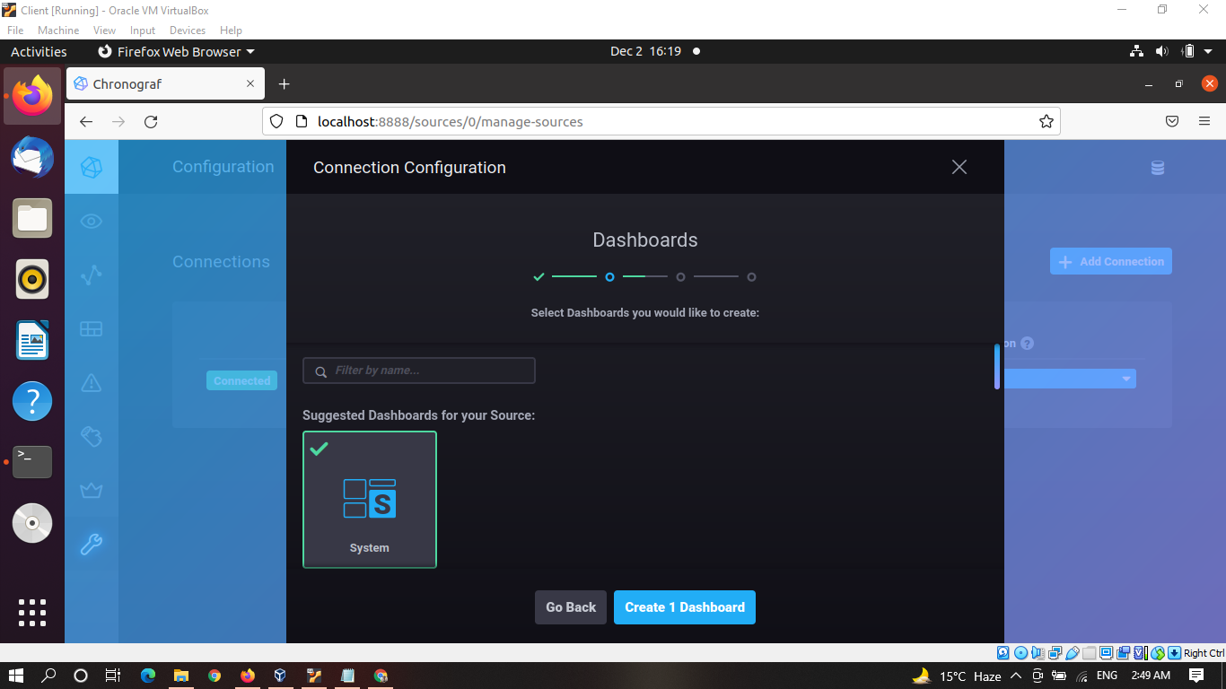

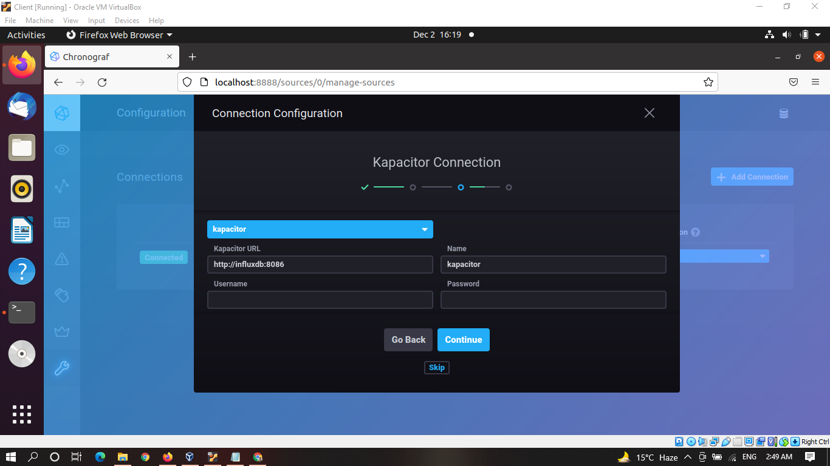

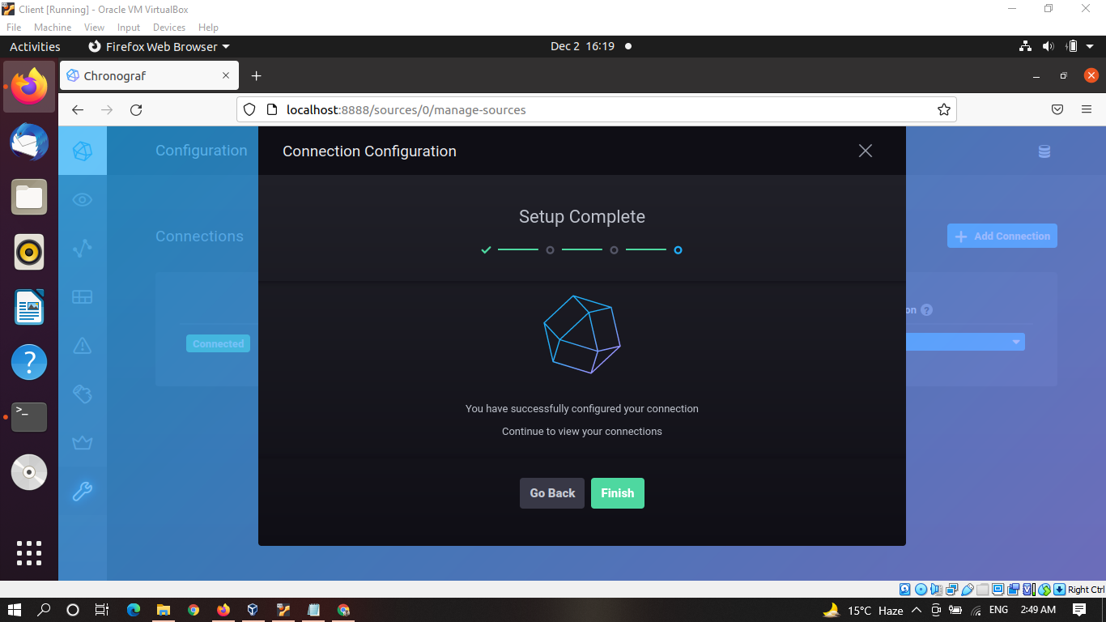

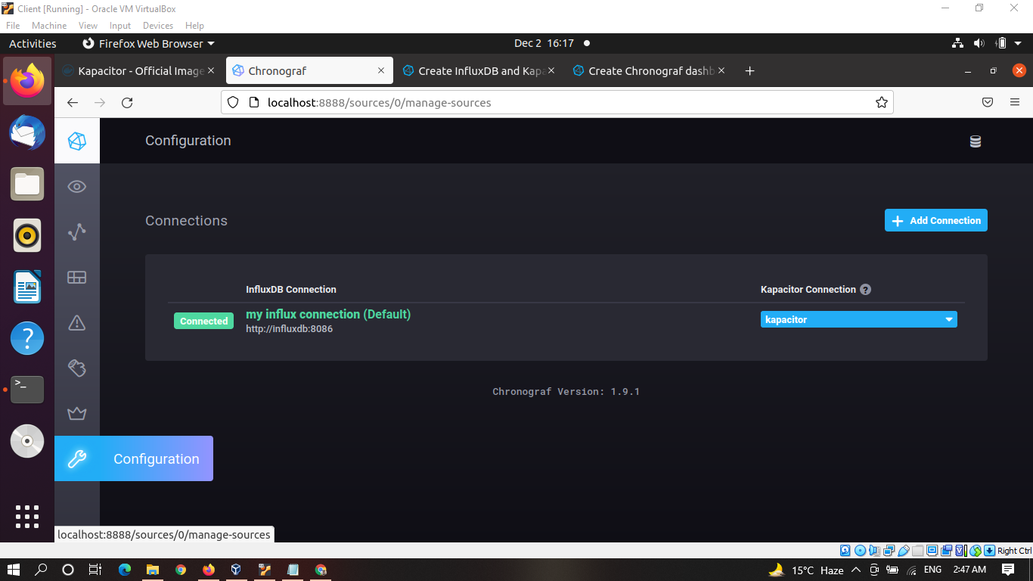

Step7: Showing Host List

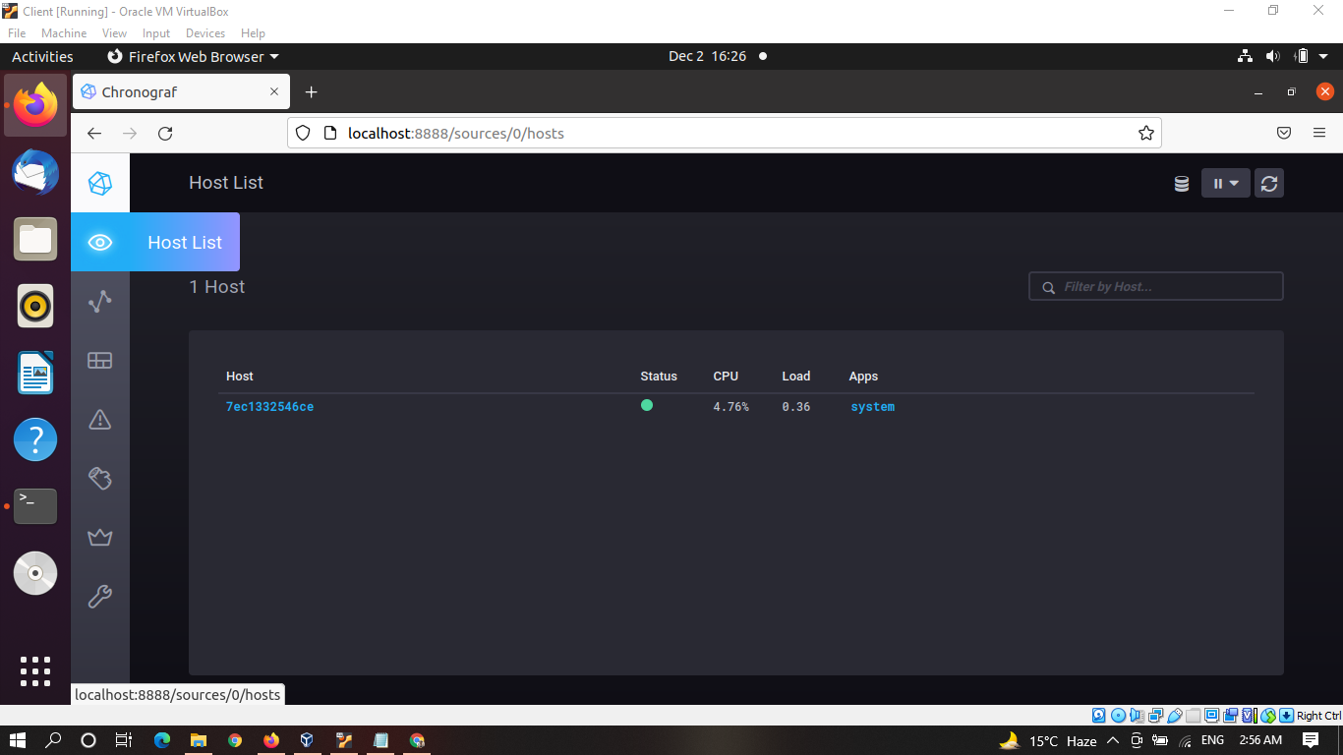

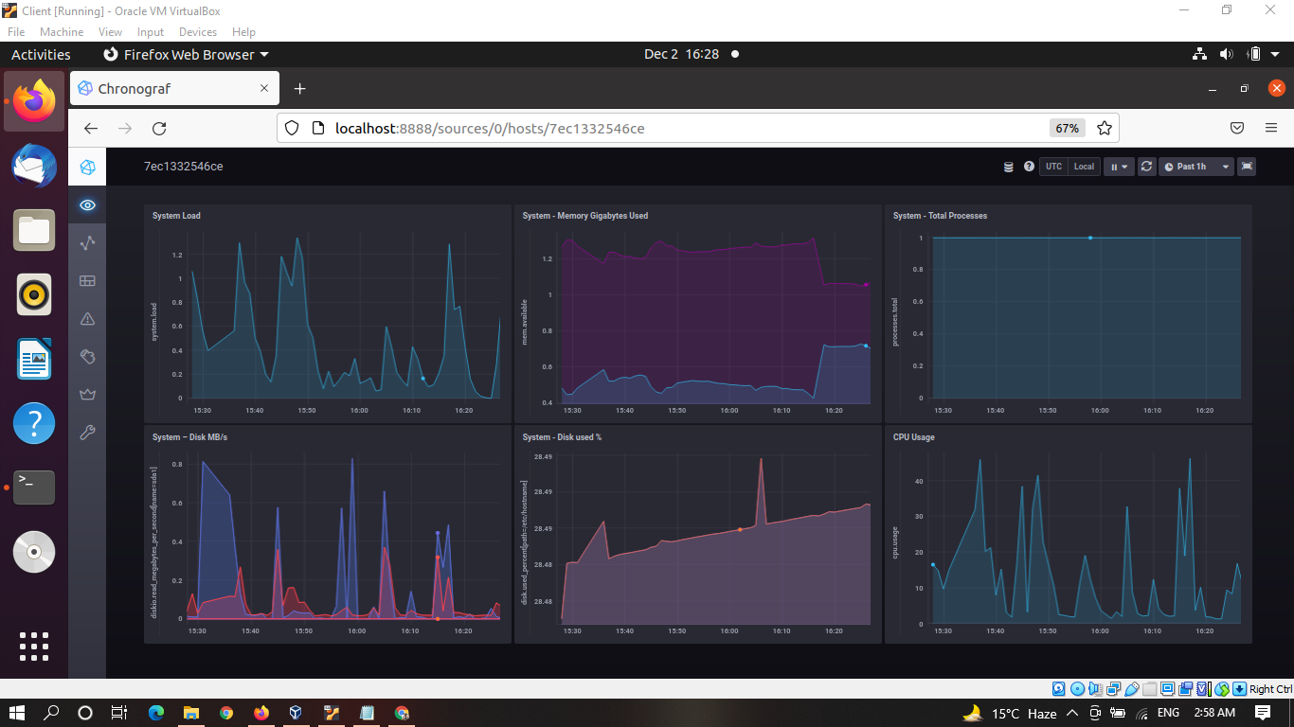

Step8: Showing Dashboard

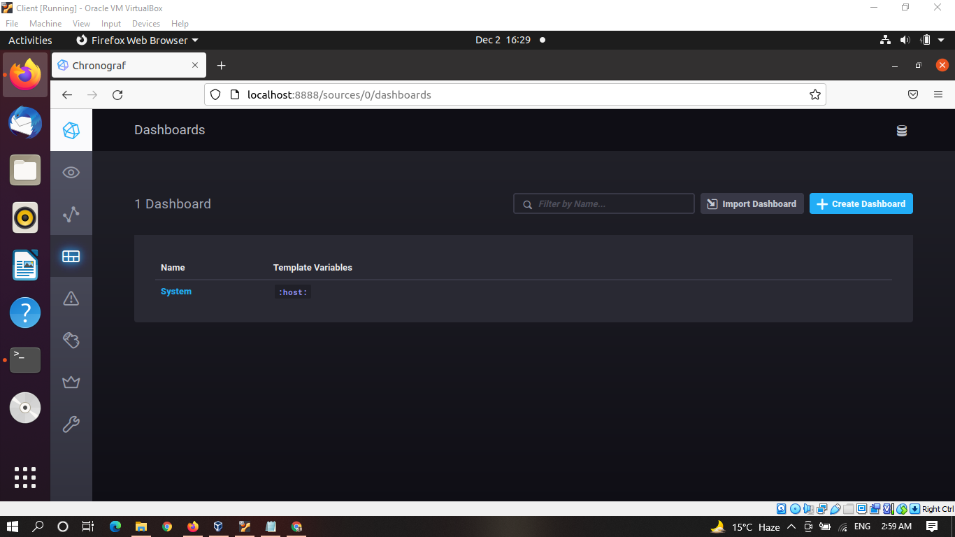

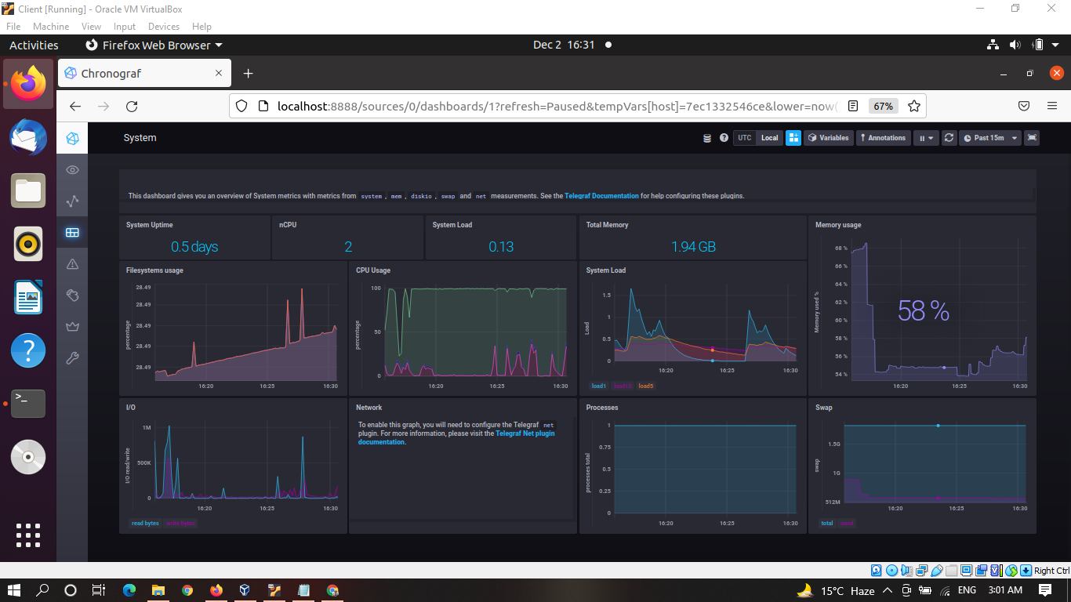

Step9: Showing InfluxDB Admin panel.

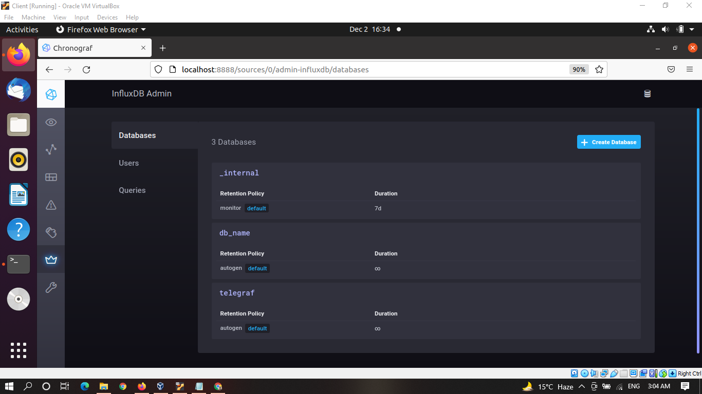

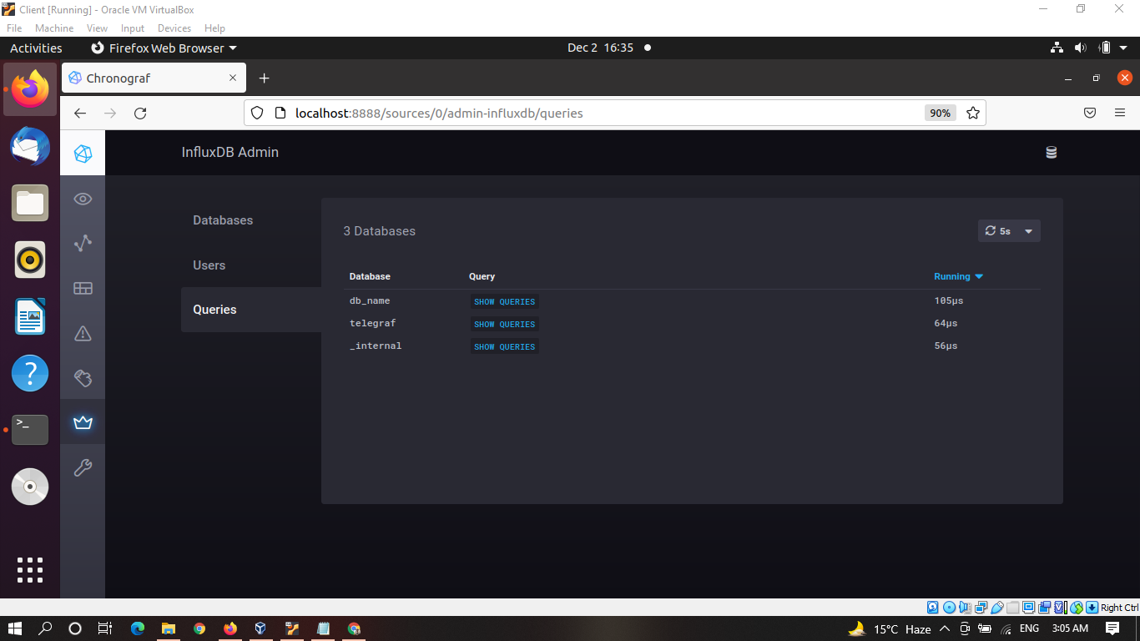

Step10: Showing the Explore panel by running some query.

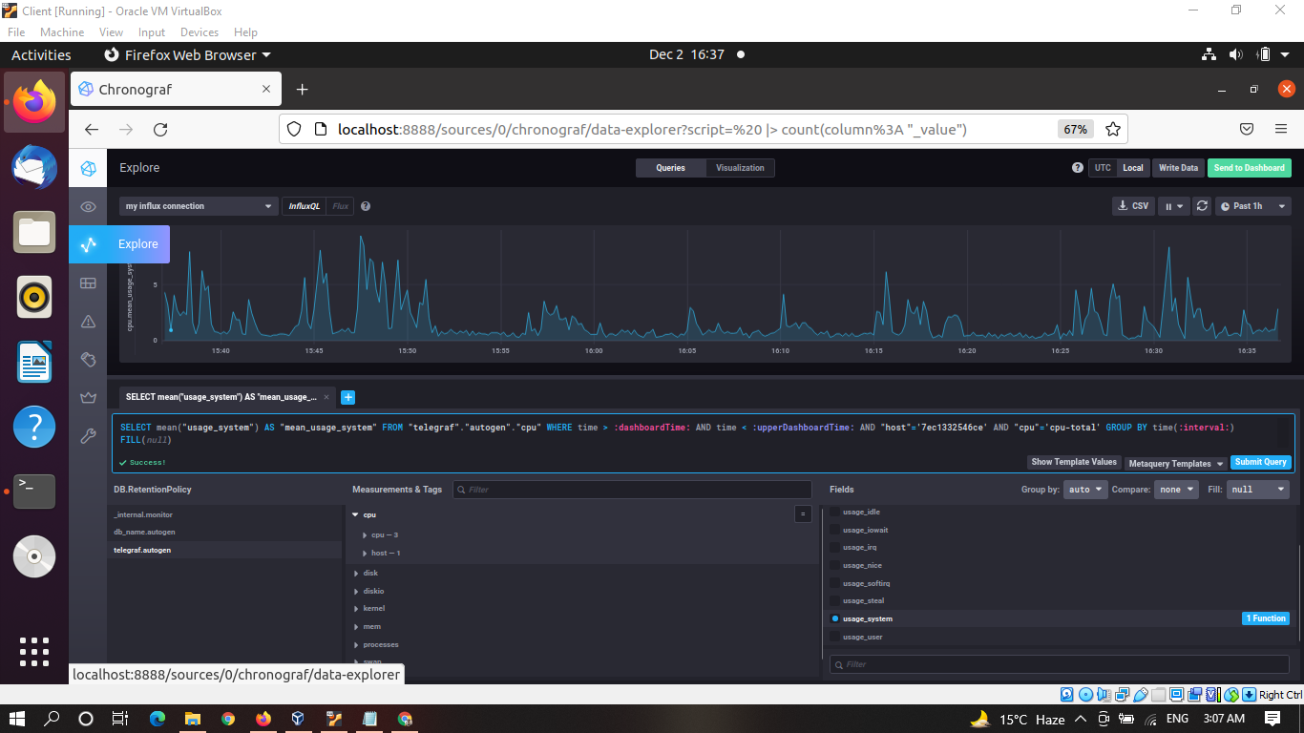

Video link : <https://youtu.be/HaNNnDUS5YE>

# References

1. <https://docs.influxdata.com/chronograf/v1.9/>
2. <https://docs.influxdata.com/kapacitor/v1.6/administration/configuration/>
3. <https://docs.influxdata.com/chronograf/v1.9/administration/creating-connections/>
4. <https://medium.com/codingtown/influxdb-tick-stack-part1-28bd04d10a18>
5. <https://www.youtube.com/watch?v=NGv7LeCaPtc>